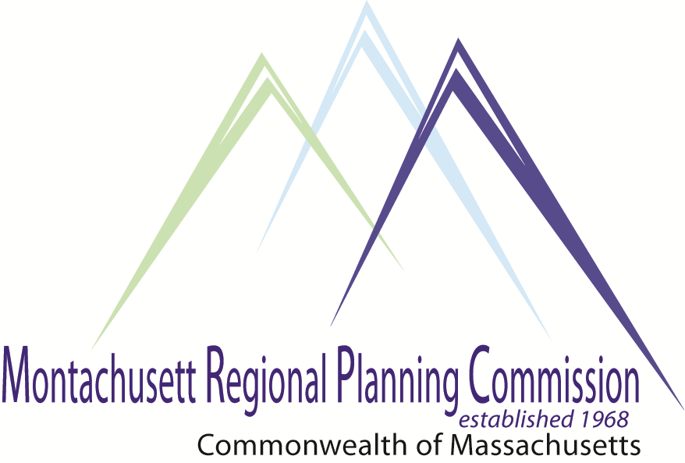

**Thursday, March 31, 2016 at 5pm**

**MRPC Conference Room**

**1427R Water Street Fitchburg, Massachusetts 01420**

**Come Join Us to hear from MA DCR representative Jeff Lacy about the concept of Natural Resource Protection Zoning!**

**A Light Dinner will be served - please RSVP by March 29, 2016 via: jhume@mrpc.org**

**5:00 PM Introductions and Welcome:** *Alan Pease, Ashby Planning Board, MRPC Treasurer*

**5:10 PM Natural Resource Protection Zoning (NRPZ)**

*Jeff Lacy, Massachusetts Department of Conservation and Recreation*

6:10 PM Montachusett Region Industrial Analysis Grant Application.

*Glenn Eaton, MRPC*

*Executive Director*

6:25 PM Administrative Matters

6:30 PM Adjournment

**C: City and Town Clerks: Please post this notice pursuant to the Open Meeting Law**

# *Comprehensive Economic Development Strategy (CEDS) Meeting*

## AGENDA